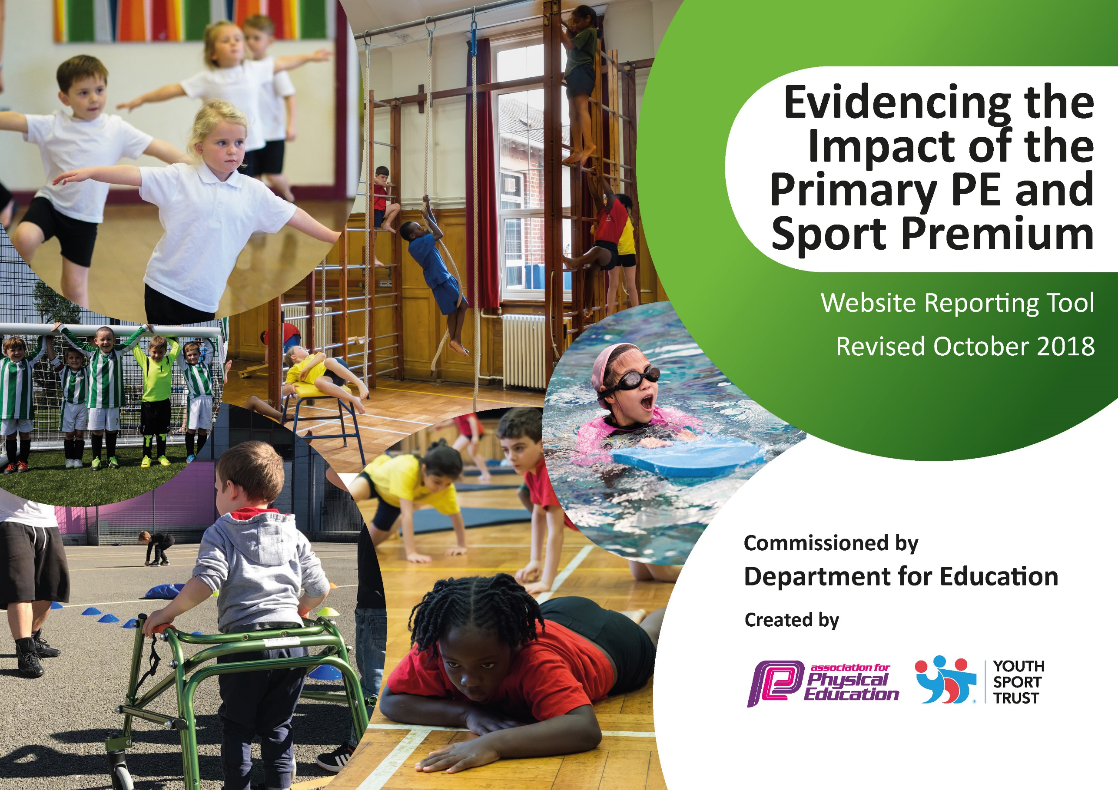

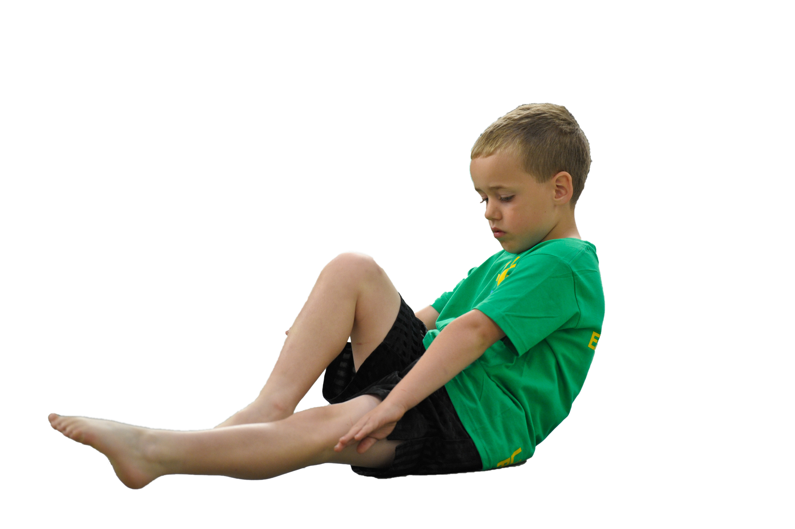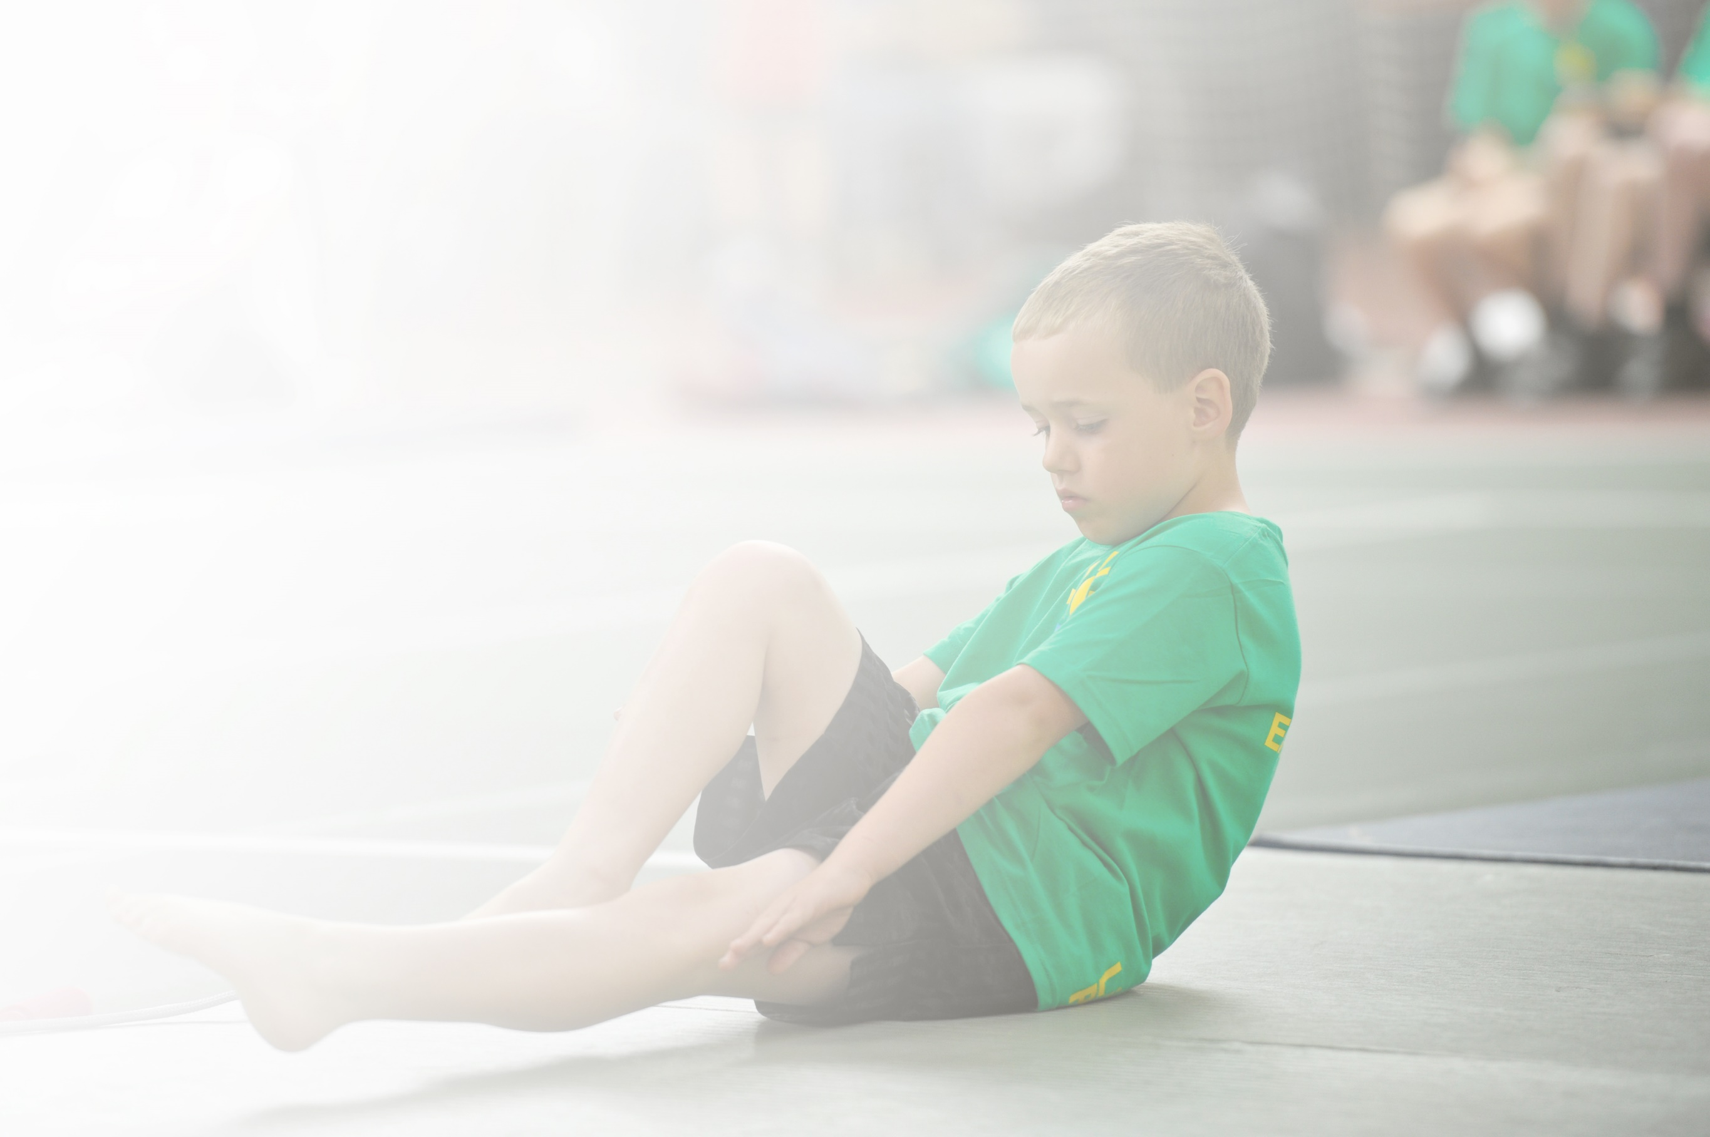Schools must use the funding to make **additional and sustainable** improvements to the quality of Physical Education, Sport and Physical Activity (PESPA) they offer. This means that you should use the Primary PE and Sport Premium to:

* Develop or add to the PESPA activities that your school already offer
* Build capacity and capability within the school to ensure that improvements made now will benefit pupils joining the school in future years

Please visit [gov.uk](https://www.gov.uk/guidance/pe-and-sport-premium-for-primary-schools) for the revised DfE guidance including the 5 key indicators across which schools should demonstrate an improvement. This document will help you to review your provision and to report

your spend. DfE encourages schools to use this template as an effective way of meeting the reporting requirements of the Primary PE and Sport Premium.

We recommend you start by reflecting on the impact of current provision and reviewing the previous

spend. Under the [Ofsted Schools Inspection Framework](https://www.gov.uk/government/publications/school-inspection-handbook-from-september-2015), inspectors will assess how effectively leaders use the Primary PE and Sport Premium and measure its impact on outcomes for pupils, and how effectively [governors](https://www.gov.uk/government/publications/governance-handbook) hold them to account for this.

Schools are required to [publish details](https://www.gov.uk/guidance/what-maintained-schools-must-publish-online#pe-and-sport-premium-for-primary-schools) of how they spend this funding as well as on the impact it has on pupils’ PE and sport participation and attainment by the end of the summer term or by **31 July 2019** at the   
latest.   
  
We recommend regularly updating the table and publishing it  
on your website throughout the year, as evidence of your   
ongoing review into how you are using the money to   
secure maximum, sustainable impact. To see an   
example of how to complete the table please   
click [HERE](http://www.afpe.org.uk/physical-education/wp-content/uploads/afPE-Example-Template-Indicator-2018-Final.pdf).

Support for review and reflection - considering the 5 key indicators from DfE, what development needs are a priority for your setting and your students now and why? Use the space below to reflect on previous spend, identify current need and priorities for the future.

|  |  |
| --- | --- |
| Key achievements to date: | Areas for further improvement and baseline evidence of need: |
| * PE is taught across the school with all classes receiving 2 hours a week. * PE is all-inclusive * CPD from skilled sport coaches to increase the confidence and skills of teachers. * Inclusion of whole school in PE, sports and activates in competitions (EAL, SEND, DAP and less active children) * Celebration of achievements in good work assembly. * Links with local sport clubs (Leicester Tigers, Leicestershire Cricket Club, ECB, Tri-golf) * Children experiencing new sports e.g mixed martials and Judo. | * Utilisation of skilled and trained members of staff (NS), to increase confidence and staff knowledge. * Increase of completive sports mainly for KS1 and KS2. * More CPD from (NS) to reduce / avoid deskilling teachers. * Observations from KH & NS to ensure a high level of PE is being taught across the school. |

|  |  |
| --- | --- |
| Meeting national curriculum requirements for swimming and water safety | Please complete all of the below: |
| What percentage of your current Year 6 cohort swim competently, confidently and proficiently over a distance of at least 25 metres?  **N.B.** Even though your children may swim in another year please report on their attainment on leaving  primary school. | 18.3% |
| What percentage of your current Year 6 cohort use a range of strokes effectively [for example, front crawl, backstroke and breaststroke]? | 17% |
| What percentage of your current Year 6 cohort perform safe self-rescue in different water-based situations? | 14% |
| Schools can choose to use the Primary PE and Sport Premium to provide additional provision for swimming but this must be for activity **over and above** the national curriculum requirements. Have you used it in this way? | NO |

**Action Plan and Budget Tracking**

Capture your intended annual spend against the 5 key indicators. Clarify the success criteria and evidence of impact that you intend to measure to evaluate for students today and for the future.

|  |  |  |  |  |
| --- | --- | --- | --- | --- |
| **Academic Year:** 2018/19 | **Total fund allocated:** £19570 | **Date Updated:** | |  |
| **Key indicator 1:** The engagement of all pupils in regular physical activity – Chief Medical Officer guidelines recommend that primary school children undertake at least 30 minutes of physical activity a day in school | | | | Percentage of total allocation: |
| % |
| School focus with clarity on intended **impact on pupils**: | Actions to achieve: | Funding allocated: | Evidence and impact: | Sustainability and suggested next steps: |
| Professional sport coaches to run activities   * Energise club (SSPAN) * SEND rugby (Leicester Tigers) * Tigers Swifts * Chance to Shire (LCC) * Tagg Do taster session * Judo Taster ( Destination British Judo Association) * Tennis Tasters ( Leicester Tennis Association) * Big Moves (SSPAN)   Tri Golf (Lead by PGA Coach)  Using websites during snack breaks, changing of lessons:   * Primary premier league * Super Movers BBC * Go noodle | Golden Ticket Club.  -Energise Club ran by the SSPAN  Less active involved, bring a friend.    **Key indicator 4**  Progress into the level 2 competition ran by the SSPAN in May.  Cross curricular activities. Active learning | £150  £50  £150 | Less active children taking part for the 12 weeks, not just doing physical activity but learning all about health and wellbeing through physical activity. Golden ticked club having a huge impact on raising the profile for PE and overall improvement of enjoyment and activity. With majority of the least active children attending the club having more active lunchtimes.  20 children with SEND took part in the Tigers SEND programme running during school time, teaching them core values such as: communication, teamwork, confidence, and enjoyment etc. 98% attendance throughout.  SEND – also had their own Judo taster session, with children enjoying and learning new skills which each child receiving a medal.  20 children learning to work as a team and individually, leaning to make decisions. | Introduce the Daily mile – to get all the children undertaking additional 15mins activity per day.  Maintain links with the Destination BJA and Leicester Tigers to provide SEND coaching.  Purchased equipment to embed Tri Golf into the curriculum. |
| **Key indicator 2:** The profile of PESSPA being raised across the school as a tool for whole school improvement | | | | Percentage of total allocation: |
| % |
| School focus with clarity on intended **impact on pupils**: | Actions to achieve: | Funding allocated: | Evidence and impact: | Sustainability and suggested next steps: |
| Celebration Assembly:  During the good work assembles every week to ensure the whole school is aware of the importance of PE and sport, also to aspire to being involved within assembles.  **Equipment:**   * SafeSport Uk to check all the sports equipment, including the outdoor adventure equipment.   **New/ update equipment:**  To be purchased to allow teachers and staff to provide best possible lessons.  -Staff Uniform  - SEND equipment  -Swim England Charter  **AFPE membership**    School Games Mark Silver for second year running – while working towards achieving Gold in 19/20.  Games mark linked with SSPAN network (Key indicator 2,3,4,5)   1. Competition entry fees 2. Reduced training costs CPD 3. Festivals 4. Conferences 5. Links with other Schools outside of the Academy 6. Increased participation in the School Games. 7. Provide existing staff with training or resources to help them teach PE and sport. 8. Provide after school clubs with a reduced fee. | Achievements celebrated during assembly (match results and notable achievements during competitions or lessons) Reports to be displayed.  To highlight any health and safety issues with equipment.  Health and Safety updates, support how spending the PE and Sport Premium.  Secured Silver Games mark for 18/19, working towards Gold games mark for 19/20 academic year. | £100  £453.00  £6000  £111  £1700 (Accounted for in Key Indicator 5) | Children are celebrated for their achievements during competitions, PE lessons, after school clubs with stickers, certificates and medals. All this promotes enthusiasm for taking part and gives the children positive reinforcement for doing physical activity.  All equipment fixed or replaced so the children are safe using the equipment during lessons.  Sports kit to be ordered to raise the standards of PE, and equipment to keep up to date and tidy.   * Staff wearing sports kit encourages and demonstrates the correct clothing when participating in sport, and also staff feel comfortable teaching PE. * Maintains high standards and good representation when at competitions. | Management of assemblies and awards, as well as using the sports leaders / sports council in the process.  Ensure the notice board is kept up to date with the results and clubs to ensure pupils are keen to get involved.  To make staff aware of the procedures to report damage equipment also to safe storage of the equipment.  To achieve Gold games kite mark in 19/20 academic year working with SLT and SSPAN. |

|  |  |  |  |  |
| --- | --- | --- | --- | --- |
| **Key indicator 3:** Increased confidence, knowledge and skills of all staff in teaching PE and sport | | | | Percentage of total allocation: |
| % |
| School focus with clarity on intended  **impact on pupils**: | Actions to achieve: | Funding  allocated: | Evidence and impact: | Sustainability and suggested  next steps: |
| Staff development and whole school training:  NS to attend ASA primary school course to assist the swim teachers teach at Aylestone Leisure Centre. | Staff to undertake CPD courses ran by the SSPAN, NS to run staff meeting.  LCC ran whole school staff meeting  Leicester Tigers teachers attending sessions as well as 1 to 1 in the SEND rugby.  NS to have own swim group (Group 3 higher ability, working  alongside ASA level 2 swim teacher). | £2000 | All staff to have CPD, areas for development identified through discussion with teachers. The CPD will boost confidence and the understanding of health and safety in teaching PE. This means the provision for the children is high quality throughout the whole school. | To ensure all new staff receive the same training as existing staff. CPD courses in specific sports such as gymnastics and few others.  When using outside agencies during school hours, class teachers to attend the sessions to avoid deskilling the teachers.  NS to run multiple staff meeting throughout the year.  Carry out PE audit, at the beginning of the 19/20 academic year. |
| **Key indicator 4:** Broader experience of a range of sports and activities offered to all pupils | | | | Percentage of total allocation: |
| % |
| School focus with clarity on intended  **impact on pupils:** | Actions to achieve: | Funding  allocated: | Evidence and impact: | Sustainability and suggested  next steps: |
| Outdoor Adventure Activity – ran by Leicester Outdoor Pursuits Centre.  Swimming:   * To ensure all swimmers achieve 25 meters, meeting the statutory requirements of the national curriculum. * All pupils can perform self-rescue over a varied distance so that the children feel safe and confident in water.   Tri-Golf - To offer the different board and balanced curricular sports:   1. Offing a different sport from the traditional sports (football, Netball, Tag-rugby) 2. Golden ticket club 3. All-inclusive sport 4. Ran by a PGA qualified coach 5. Team building   Offer choice and diversity in PE and Sport.  Develop an offer for all, including traditional sports, alternative sports and physical activity. Linking with cross curricular activities. Offer competitive sport for a wider range of children including SEND, DAP, less active.  Big Moves   * Better listening and concentration * Improved ability to follow instructions. * Better posture, no longer slumping in chairs * More imagination and creativity * Improved ability to sit still and less fidgeting * Improved hand writing * Greater confidence * Better vocabulary about own bodies | Choose activities to challenge the children individually and within a team.  Swim England swim charter  -Affiliation to Swim England (formally known as ASA) providing certificates, CPD, planning and ideas to support and promote swimming.  To enter the Tri-Golf competition arranged by SSPAN at Humberstone Heights Gold Club.  Leicester Tigers Swifts  Leicester Tigers SEND rugby  Leicester Shire Cricket Club (LCC)Chance to Shine    Leicester City School Sport, Physical Activity Network (SSPAN) | £3500  £36 (including VAT)  £150 (Accounted for in Key Indicator 1)  £50 (Accounted for in Key indicator 1) | Experience and part take in Outdoor adventures activities, also allows the children to experience different activities within a safe environment.  Maintain links with other schools and pools with the Swim England charter / affiliation. Learning from the pools and other schools of best practice.  Children experience a different sport  After school club full each week for 6 weeks, with children attending games with their parents and family. With handful of boy and girls playing tag and contact rugby before and during the game.  20 children with SEND took part in the Tigers SEND programme running during school time, teaching them core values such as: communication, teamwork, confidence, enjoyment etc.  Both Year 3 classes participated for a block of 6 weeks on a Friday morning. With cross curricular activities being taught during lesson time linking to cricket.  Created a link with ECB, looking to start a mothers and daughters session/sessions.  Children highlighted by class teachers. Learning new skills and improving existing skills for class room based lessons. | Identify any outdoor adventures activities that the children can experience at school (orienteering) and train staff.  Teacher / support staff identified to gain knowledge of how to support pupils in the water.  Year 6 to have swimming boosters to ensure the maximum number of children leave being able to swim 25 meters.  Purchase equipment (NS) to train sport leaders and staff.  Maintain a strong relationship with the Tigers, to make sure it carries on the following year. Teachers to watch the Tigers coach as part of the CPD / Tigers coach to run a Staff meeting.  1 t o1 attend all the sessions. Start to participate with the children during the sessions to give them CPD to help with during PE lessons.  Maintain a strong relationship with LCC to make it follows on the next year. Teachers attend the sessions participates with the children CPD for the teachers.  Send members of staff on Big Moves CPD course including (NS) to carry out whole school staff meeting. |
| **Key indicator 5:** Increased participation in competitive sport | | | | Percentage of total allocation: |
| % |
| School focus with clarity on intended  **impact on pupils**: | Actions to achieve: | Funding  allocated: | Evidence and impact: | Sustainability and suggested  next steps: |
| Increased participation in competitive sports – Entering more competitive sports events for all. Membership to the SSPAN:   1. Competition entry fees 2. Reduced training costs CPD 3. Festivals 4. Conferences 5. Links with other Schools outside of the Academy 6. Increased participation in the School Games. 7. Provide existing staff with training or resources to help them teach PE and sport. 8. Provide after school clubs with a reduced fee.   Membership ST Pauls secondary school Feeder, school link competition.  Transport Costs (Leicester City Bus companies)   * Woods * Confidence | School Sport & Physical Activity Network (SSPAN) membership:   1. Enter an increased number of competitions from the SSPAN. 2. More Parallel/SEND sports event entered.   Attend all the Year group sport festivals held throughout the year.  Transport to level 2 competitions lead by the SSPAN. | £1700  £2000  £2000 | Entering level 2 competitions, which gives the children a purpose to participate in sport. Maintain and create new links with other schools and staff within the City Sports Partnership. Attending conferences, CPD courses and meeting, to ensure Sacred Heart is up to date with the current developments in sport education.  Competitions provides children with a purpose to participate in sport, also enables them to learn new skills e.g. social, communication, teamwork, leadership and decision making. Competitions also promote an active lifestyle.  Saffron Lane Athletics Competition:  Year 3 /4 finishing 1st In East Leicester on 130 points, second the year before.  Year 5 / 6 finishing 2nd 230 points same position as previous year.  All year groups qualifying for Quad Kids completion.  Year 6 boy finishing 3rd on total points scored at Quad kids.  Every child participating in Sports festivals from every year group.  Transport is essential for children to be able to participate in sport against other schools within Leicester as it promotes an active lifestyle. | Increased opportunities for KS1 with competitions and festivals being offered with the SSPAN.  Increase competitions and events held within school both intra and inter.  To attend all competitions entered, when returning the intention to compete form to the SSPAN, to increase the number of children participating in level 2 competitions. |