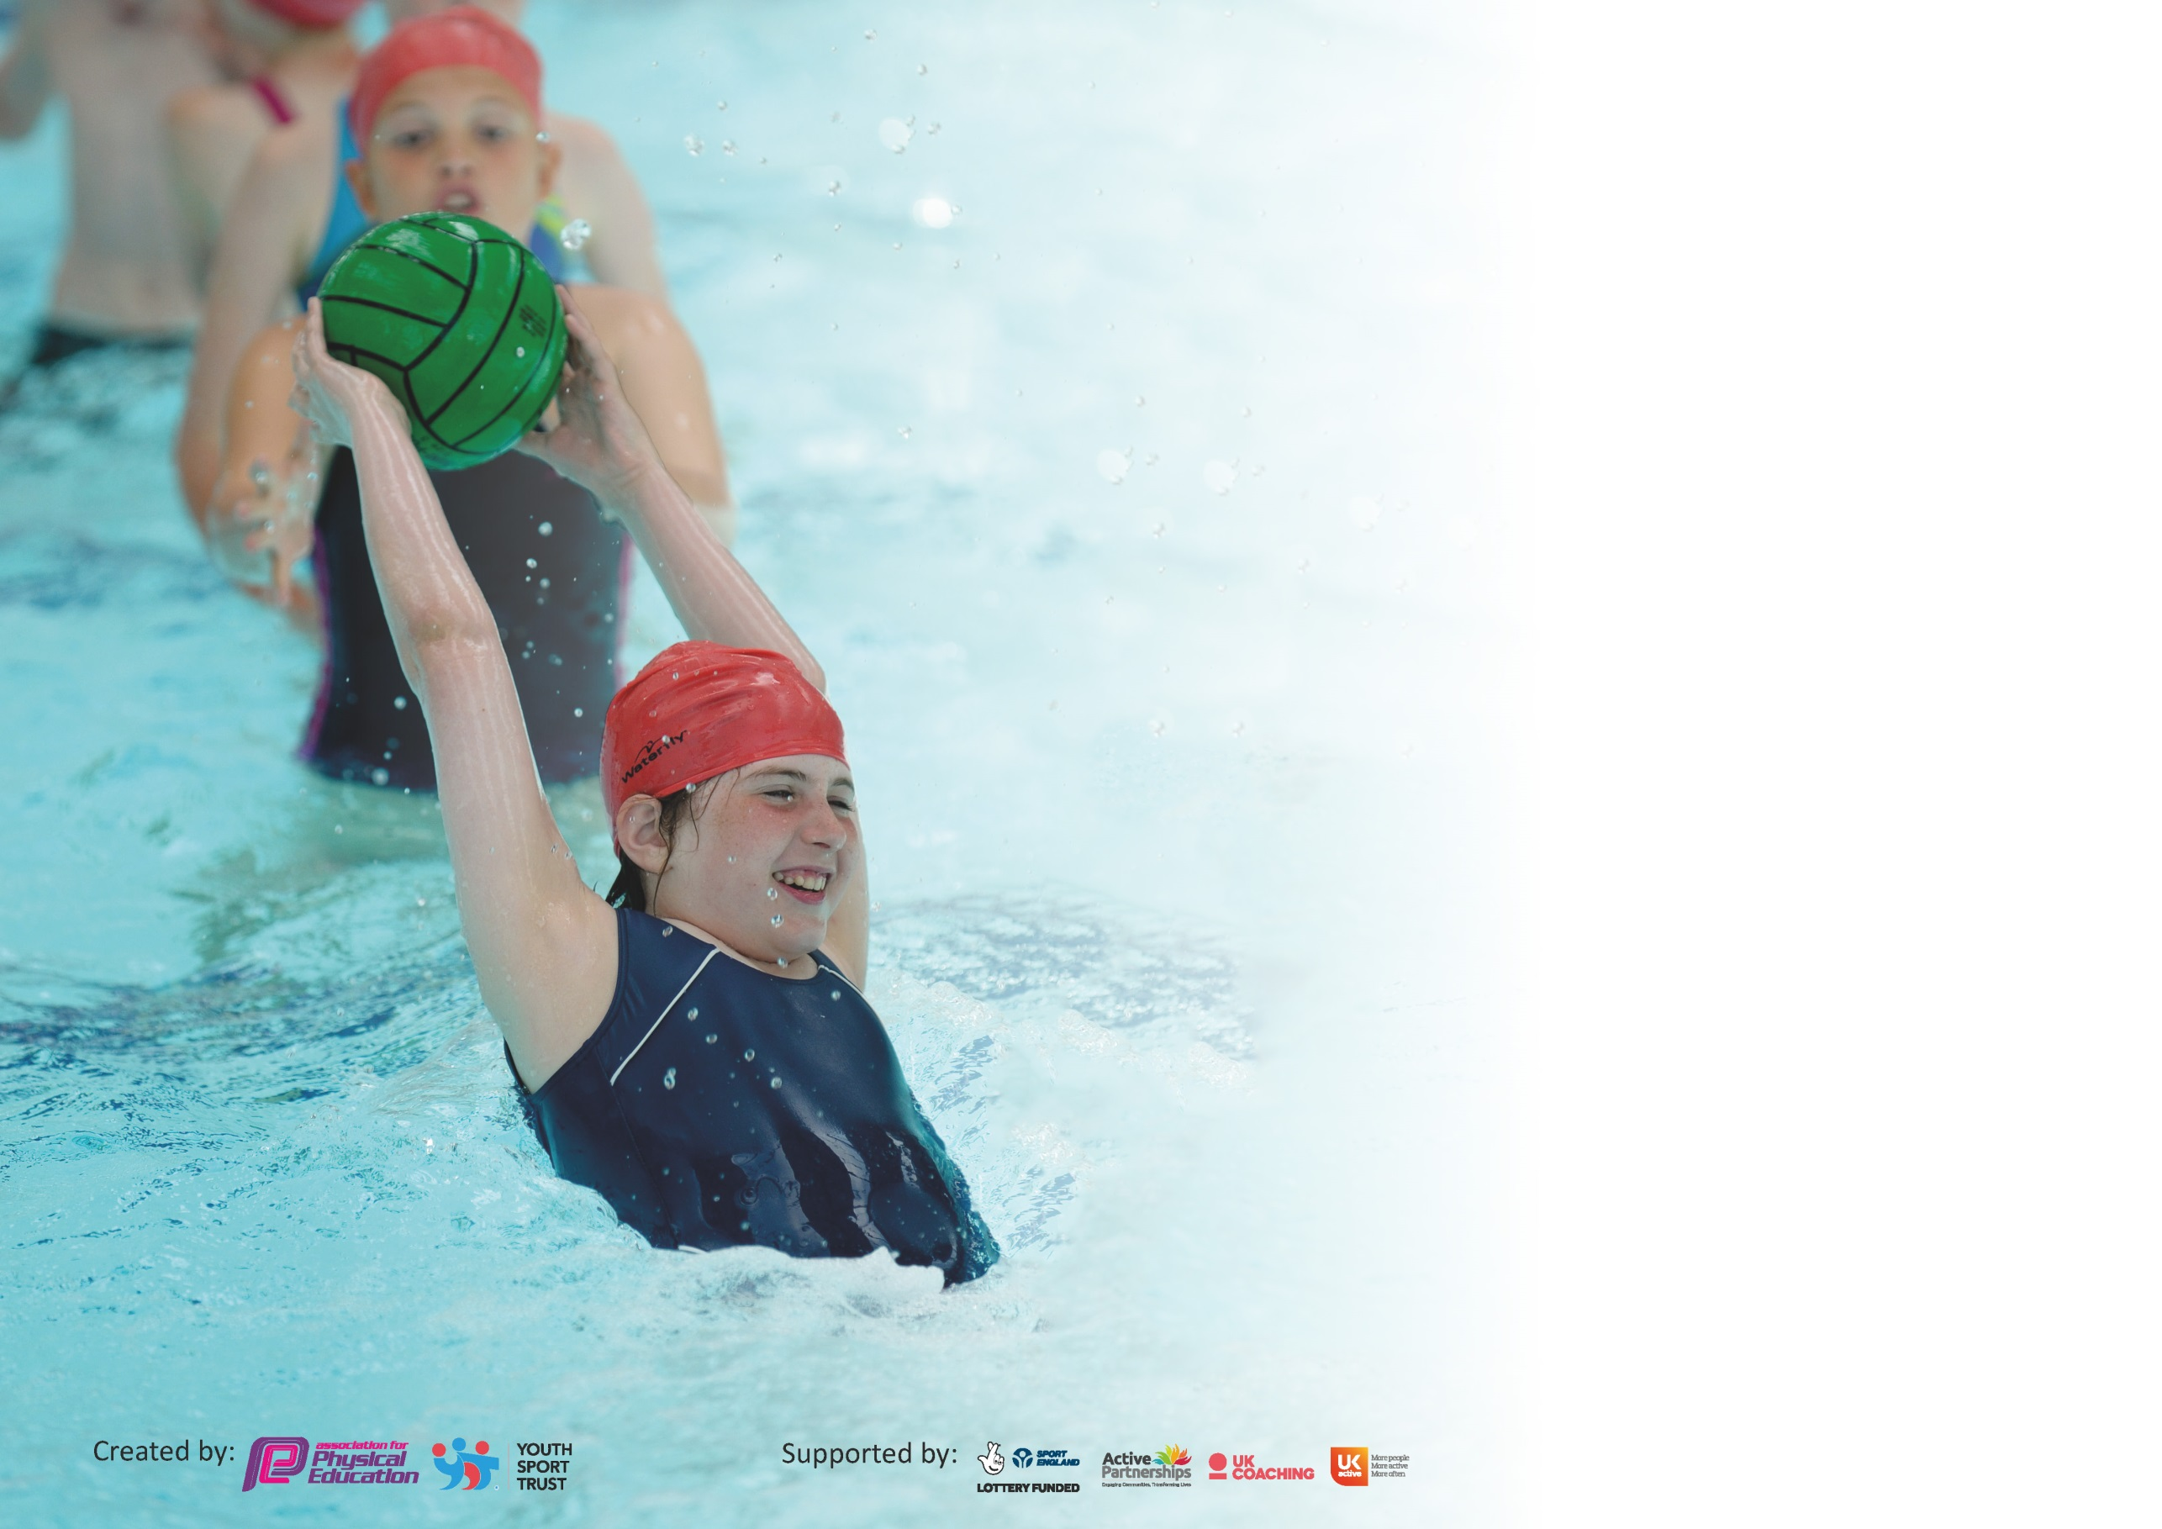

It is important that your grant is used effectively and based on school need. The Education Inspection Framework (Ofsted 2019 p64) makes clear there will be a focus on ‘whether leaders and those responsible for governors all understand their respective roles and perform these in a way that enhances the effectiveness of the school’.

Under the Quality of Education criteria (p41) inspectors consider the extent to which schools can articulate their curriculum (INTENT), construct their curriculum (IMPLEMENTATION) and demonstrate the outcomes which result (IMPACT).

To assist schools with common transferable language this template has been developed to utilise the same three headings which should make your plans easily transferable between working documents.

Schools must use the funding to make additional and sustainable improvements to the quality of Physical Education, School Sport and Physical Activity (PESSPA) they offer. This means that you should
use the Primary PE and Sport Premium to:

- Develop or add to the PESSPA activities that your school already offer
- Build capacity and capability within the school to ensure that improvements made now will benefit pupils joining the school in future years

Please visit gov.uk for the revised DfE guidance including the 5 key indicators across which schools should demonstrate an improvement. This document will help you to review your provision and to report your spend. DfE encourages schools to use this template as an effective way of meeting the reporting requirements of the Primary PE and Sport Premium.

We recommend you start by reflecting on the impact of current provision and reviewing the previous spend.

Schools are required to publish details of how they spend this funding as well as on the impact it has on pupils’ PE and sport participation and attainment by the end of the summer term or by 31st July 2020 at the latest.

We recommend regularly updating the table and publishing it on your website throughout the year. This evidences your ongoing self-evaluation of how you are using the funding to secure maximum, sustainable impact. Final copy must be posted on your website by the end of the academic year and no later than the 31st July 2020. To see an example of how to complete the table please click HERE.

Support for review and reflection - considering the 5 key indicators from DfE, what development needs are a priority for your setting and your pupils now and why? Use the space below to reflect on previous spend and key achievements and areas for development.

Key achievements to date until July 2020: | Areas for further improvement and baseline evidence of need:
- PE is taught across the whole school with all classes receiving a minimum of 2 hours.  - PE is all-inclusive.  - CPD from skilled sports coaches to increase the confidence and skills of teachers.  - Inclusion of whole school in PE, sports and competitions (EAL, SEND, DAP and less active children)  - Celebration of achievements in good work assembly.  - Participation with the wider community and other local schools – through the SSPAN, Leicester Tigers and Leicestershire Cricket Club.  - Reinforcement of respect and sportsmanship  - Employing the ‘Spirit of the Games’ 6 values: Passion, Self-belief, Respect, Honestly, Teamwork and Determination. | - More CPD from NS to avoid the deskilling of teachers in PE.  - Observations from KH and NS to ensure a high level of PE is being taught across the whole school.  - Maintenance and up keep of the PE equipment and store cupboard.  - Increase of competitive opportunities KS1.  - Sport leaders / Sports Council to have more responsibility and to engage more with the teachers and children.  - Further Implementation of the new Merton Scheme of Work across the school  - Increased involvement in extra-curricular activities and PE enrichment activities (Introduction of new sports clubs and lunch time activities

Meeting national curriculum requirements for swimming and water safety.
What percentage of your current Year 6 cohort swim competently, confidently and proficiently over a distance of at least 25 metres?  N.B. Even though your pupils may swim in another year please report on their attainment on leaving  primary school at the end of the summer term 2020. | 18%
What percentage of your current Year 6 cohort use a range of strokes effectively [for example, front crawl, backstroke and breaststroke]? | 18%
What percentage of your current Year 6 cohort perform safe self-rescue in different water-based situations? | 13%
Schools can choose to use the Primary PE and Sport Premium to provide additional provision for swimming but this must be for activity over and above the national curriculum requirements. Have you used it in this way? | Part of the funding was ear marked for the current year 6 to undertake swimming boosters but due to COVID was cancelled.

Due to Covid the school will be carrying over approximately £5000 of the 19/20 PE and Sport Premium over to next year, this will be clearly shown on the action plan for next year highlighting what the £5000 will be used for.
Action Plan and Budget Tracking
Capture your intended annual spend against the 5 key indicators. Clarify the success criteria and evidence of impact that you intend to measure to evaluate for pupils today and for the future.

Academic Year: 2019/20 | Total fund allocated: £19530 | Date Updated: August 2020
Key indicator 1: The engagement of all pupils in regular physical activity – Chief Medical Officer guidelines recommend that primary school pupils undertake at least 30 minutes of physical activity a day in school |  |  |  | Percentage of total allocation:
 |  |  |  | 1.5%
Intent | Implementation |  | Impact
Your school focus should be clear what you want the pupils to know and be able to do and about  what they need to learn and to  consolidate through practice: | Make sure your actions to achieve are linked to your intentions: | Funding allocated: | Evidence of impact: what do pupils now know and what can they now do? What has changed?: | Sustainability and suggested next steps:
Professional sport coaches to run activities  - Energise club (SSPAN)  - SEND rugby (Leicester Tigers)  - Tigers Swifts  - Chance to Shire (LCC)  - Big Moves (SSPAN)  - Balance Ability (SSPAN)  - Rugby Reading (Leicester Tigers, National Literacy Trust)  - Leicester City football club  Using websites during snack breaks, changing of lessons:  - Primary premier league  - Super Movers BBC  - Go noodle  - Active Anta (SSPAN) | -Energise Club ran by the SSPAN  Less active involved, bring a friend.  Key Indicator 4:  Cross curricular activities. Active learning  Home Learning programme launched by the SSPAN during lockdown. Was posted in Physical Education page during lockdown. | £ 300 | Due to Covid not all of the activities were completed or undertaken.  - Energise ( Not undertaken)  - SEND rugby ( Not undertaken)  - Balance Ability ( Not undertaken)  - Rugby Reading (Incomplete)  - Big Moves ( Not undertaken)  - Chance to Shine ( Incomplete)  The Rugby and Cricket programmes have had a huge impact on raising the profile of PE and contributing to an overall school improvement of enjoyment and activity of pupils in PE, who were previously less active or reluctant to join in. | All activities that were not covered or were incomplete will revisited next year to make sure that all children have to opportunity to participate.  CPD for staff on some activities so the activities can run the whole year round. Allowing more children to access the activities.  Use some of the ideas when the children are returning back to school.
Key indicator 2: The profile of PESSPA being raised across the school as a tool for whole school improvement |  |  |  | Percentage of total allocation:
 |  |  |  | 30%
Intent | Implementation |  | Impact
Your school focus should be clear what you want the pupils to know and be able to do and about  what they need to learn and to  consolidate through practice: | Make sure your actions to achieve are linked to your intentions: | Funding allocated: | Evidence of impact: what do pupils now know and what can they now do? What has changed?: | Sustainability and suggested next steps:
Celebration Assembly:  During the good work assembles every week to ensure the whole school is aware of the importance of PE and sport, also to aspire to being involved within assembles.  Equipment:  - SafeSport Uk to check all the sports equipment, including the outdoor adventure equipment.  AFPE membership  New/ update equipment:  To be purchased to allow teachers and staff to provide best possible lessons.  -Staff Uniform  -SEND equipment  - New equipment  Games mark linked with SSPAN network (Key indicator 2,3,4,5)  - Competition entry fees  - Reduced training costs CPD  - Festivals  - Conferences  - Links with other Schools outside of the Academy  - Increased participation in the School Games.  - Provide existing staff with training or resources to help them teach PE and sport.  - Provide after school clubs with a reduced fee. | Achievements celebrated in assembly match results and noticeable achievements in lessons. Leicester Tigers running celebration assembly of children participating in rugby matches for the tigers at weekends. Also noticeable achievement of a child being named captain.  To highlight any health and safety issues with equipment.  Health and Safety updates, support how spending the PE and Sport Premium.  Secured Silver Games mark 19/20. | £144 (inspection cost) £233.84 to fix all hooks on benches.  £176 (PESP Physical Education & Sport Pedagogy Journal)  £3500 on equipment  £310 on uniform  £1500 Accounted for in Key Indicator 5 | More girls asking about the tigers club and attending other rugby clubs outside of school ran by the tigers. All due to a girl being named captain and receiving a personalized shirt.  Wider Impact of above:  - Pupils are very proud to be involved in assembles / photos on notice boards which is impacting on confidence and self-esteem.  All equipment fixed or replaced so the children are safe using the equipment during lessons.  Sports kit to be ordered to raise the standards of PE, and equipment to keep up to date and tidy.  - Staff wearing sports kit encourages and demonstrates the correct clothing when participating in sport, and also staff feel comfortable teaching PE.  - Maintains high standards and good representation when at competitions.  Due to Covid the school wasn’t able to apply for Gold and was awarded silver for the year. This was done because:  - Missed Competitions  - Missed opportunities for B and C teams. | To run more after school clubs with the tigers, to publish information on other clubs ran outside of school.  Management of assemblies and awards, as well as using the sports leaders / sports council in the process.  To make staff aware of the procedures to report damage equipment also safe storage of the equipment.  Due to Covid not all equipment was ordered, this will be revisited during the teacher training days of next year to do an equipment audit.  To achieve Gold games kite mark in 20/21 academic year working with SLT and SSPAN.

Key indicator 3: Increased confidence, knowledge and skills of all staff in teaching PE and sport |  |  |  | Percentage of total allocation:
 |  |  |  | 13%
Intent | Implementation |  | Impact
Your school focus should be clear | Make sure your actions to | Funding | Evidence of impact: what do | Sustainability and suggested
what you want the pupils to know | achieve are linked to your | allocated: | pupils now know and what | next steps:
and be able to do and about | intentions: |  | can they now do? What has
what they need to learn and to |  |  | changed?:
consolidate through practice:
Implementation of whole school Scheme of Work:  Ensure all staff are confident and comfortable with the use and employment of lesson plans.  - Staff meeting to be held on the SOW to answer any questions from staff.  - Staff training to apply and use SOW correctly and effetely.  Staff development and whole school training:  - EH to attend ASA primary school to assist in with swim teachers.  - NS to attend Mental Health First Aid.  - NS to attend a refresher First Aid at work. | Merton Scheme of work and planning. All schemes of work to be purchased and given to all staff. Also online logins given to all year group staff.  Staff to undertake CPD courses ran by the SSPAN, NS to run staff meeting.  - Leicestershire Cricket Club to run staff meeting. | £1100  £1500 | Clear progression throughout the year group through the implementation of whole school scheme of work.  All staff to have CPD, areas for development identified through discussion with teachers. The CPD will boost confidence and the understanding of health and safety in teaching PE. This means the provision for the children is high quality throughout the whole school. | Observe and audit staff at times throughout the year to perceive staff’s confidence and understanding in the implementation of the SOW.  More CPD available to school staff to avoid deskilling teachers.  To ensure all new staff receive the same training as existing staff. CPD courses in specific sports such as gymnastics and a few others.  When using outside agencies during school hours, class teachers to attend the sessions to avoid deskilling the teachers.  NS to run multiple staff meeting throughout the year.
Key indicator 4: Broader experience of a range of sports and activities offered to all pupils |  |  |  | Percentage of total allocation:
 |  |  |  | 34%
Intent | Implementation |  | Impact
Your school focus should be clear | Make sure your actions to | Funding | Evidence of impact: what do | Sustainability and suggested
what you want the pupils to know | achieve are linked to your | allocated: | pupils now know and what | next steps:
and be able to do and about | intentions: |  | can they now do? What has
what they need to learn and to |  |  | changed?:
consolidate through practice:
Outdoor Adventure Activity – ran by Leicester Outdoor Pursuits Centre.  Offer choice and diversity in PE and Sport.  Develop an offer for all, including traditional sports, alternative sports and physical activity. Linking with cross curricular activities. Offer competitive sport for a wider range of children including SEND, DAP, less active.  Balance Ability SSPAN and ST Pauls  Swimming Boosters for Year 6  Sports Days to focus on ALL children participating in active sports and activities across the school – Increased competitiveness. Rewards (Stickers, Trophies, certificates).  Leicester City Football Club Competition  -Year 5 and 6 boys football team | Choose activities to challenge the children individually and within a team.  Leicester Tigers Swifts after school club.  Leicester Tigers Rugby Reading  Leicester Shire Cricket Club (LCC)Chance to Shine  Children that were highlighted during PE and lunch times. To undertake 6 weeks of lessons by and SSPAN and ST Pauls to make sure all the children have the opportunity.  Highlighted children from the Swimming Coordinator NS we below to undertake a 6 week intensive block of lessons to help the children meet the national curriculum requirements.  Continue to develop Sports day to be fun, enjoyable and fully inclusive for all across the whole school.  Children who attended football club afterschool were invited to attend a football competition ran by Leicester City football club. | £3500  Key indicator 1  £2500  £600 cost of travel. | Due to covid we have cancelled OAA activities. All activities that were cancelled this year will be revisited next year to make sure all the children have opportunities to participate.  More participate in the after school club this year, with more children attending the Tigers Swift club outside of school. With one child being named captain and being presented with a personal shirt during assembly.  Both Year 3 classes participated for a block of 6 weeks on a Tuesday afternoon. With cross curricular activities being taught during lesson time linking to cricket. (Incomplete due to covid)  Due to Covid we had to cancel balance ability. This will be revisited next year to make sure the children still have the opportunity to access it.  Due to covid we had to cancel the swimming boosters for year 6. This will be revisited for next year as one year 5 class missed a term of swimming lessons.  With sports day being fully inclusive allows the children to be proud of their achievements. Parents involved and enjoying the day.  Due to Covid sports day was cancelled.  The year 5 and 6 boys football team played 4 matches winning 3 and drawing 1. Finishing joint top of the table, buy narrowly missing out on the finals due to the team progressing to the finals going through on goals scored. | Identify any outdoor adventures activities that the children can experience at school (orienteering) and train staff.  Maintain strong relationship with Leicester Tigers to run the club next year.  Tigers Rugby Reading Champions to be started next year to promote and link a love a sport with a cross curricular activity  Maintain a strong relationship with LCC to make sure it follows on the next year. Teachers attend the sessions participates with the children CPD for the teachers.  Look into the cost of equipment and CPD for staff to attend from school to run more sessions.  Look into 12 week intensive swimming block to make up for missed lessons.  To model the KS2 around the Quad Kids format to allow for more competitive activities.  Maintaining the link with Leicester City Football Club to attend next year. Also to enter a girls football team.

Key indicator 5: Increased participation in competitive sport |  |  |  | Percentage of total allocation:
 |  |  |  | 20.5%
Intent | Implementation |  | Impact
Your school focus should be clear | Make sure your actions to | Funding | Evidence of impact: what do | Sustainability and suggested
what you want the pupils to know | achieve are linked to your | allocated: | pupils now know and what | next steps:
and be able to do and about | intentions: |  | can they now do? What has
what they need to learn and to |  |  | Changed?:
consolidate through practice:
Increased participation in competitive sports – Entering more competitive sports events for all. Membership to the SSPAN:  - Competition entry fees  - Reduced training costs CPD  - Festivals  - Conferences  - Links with other Schools outside of the Academy  - Increased participation in the School Games.  - Provide existing staff with training or resources to help them teach PE and sport.  - Provide after school clubs with a reduced fee.  Membership ST Pauls secondary school Feeder, school link competition.  Transport:  Transport is essential to enable our children to experience competition further afield. | School Sport & Physical Activity Network (SSPAN) membership:  - Enter an increased number of competitions from the SSPAN.  - More Parallel/SEND sports event entered.  - Sign up to the Energise club for the less active children.  - Sign up to balance ability.  ST Pauls membership:  - Attend all football competitions for both KS1 and KS2.  - Attend all sport festivals offered to KS1 and KS2.  - Balance ability  Transport Cost:  - Transport to events to ensure we are maximising the competition calendar and allowing as many pupils to experience competitive sport. | £1500  £600  £2000 | Entering level 2 competitions, which gives the children a purpose to participate in sport. Maintain and create new links with other schools and staff within the City Sports Partnership. Attending conferences, CPD courses and meeting, to ensure Sacred Heart is up to date with the current developments in sport education.  Competitions provides children with a purpose to participate in sport, also enables them to learn new skills e.g. social, communication, teamwork, leadership and decision making. Competitions also promote an active lifestyle.  Sport leaders training for year 5 pupils to run sports at lunch times with both KS1 and KS2 children.  Not all competitions were attended from March onwards due to COVID.  Energise and balance ability have been impacted by:  Goals (football) tournaments were attended where 1st and 2nd place finishes.  Year 1 and 2 key stage festivals attended where the children experienced competitive and friendly activities.  Years 3,4,5 and 6 sports festivals all impacted by Covid.  Transport is essential for children to be able to participate in sport against other schools within Leicester as it promotes an active lifestyle. | Increased opportunities for KS1 with competitions and festivals being offered with the SSPAN.  Increase competitions and events held within school both intra and inter.  To attend all competitions entered, when returning the intention to compete form to the SSPAN, to increase the number of children participating in level 2 competitions.

Signed off by
Head Teacher:
Date:
Subject Leader:
Date:
Governor:
Date:

