Stages children learn to read
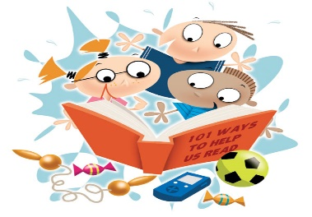

- Turn the pages themselves and make the story up from the pictures
- Say some repeated words from the book as they look at the pictures
- Remember the whole story from memory (if read a lot to them)
- Can answer questions what, why, who, when? Can guess what will happen next.
- Putting their finger under the words and making up the story
- Noticing the sounds and pointing to them
- Saying the sounds in a word c-a-t (This is called segmenting)
- Hearing the word when an adult segments c-a-t
- Segmenting the sounds then blending them together to make a word themselves c-a-t …… cat This stage can take a long time to develop but if the children read every day at home this will speed up this stage of reading.
- Recognising common exception words in the book I the to into
- Beginning to read a simple sentence ‘the cat’ by segmenting and blending the word and recognising the common exception word.
- Reading a longer sentence ‘The cat on a mat’ segmenting/blending and recognising a common exception word
- Reading a sentence with simple words and attempting to segment and blend longer words using their phonic knowledge of Phase 2 and 3 sounds. The snail was slow but the cat was fast

