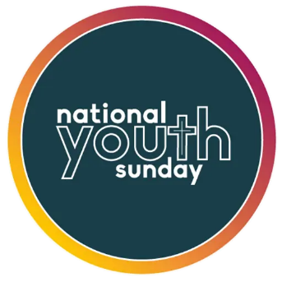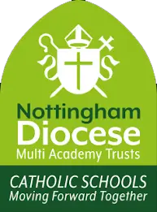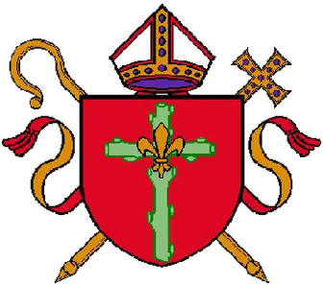

This Thursday, the 18th, is National Youth Funday. Children will be joining in the fun along with other children in Catholic schools across the country.
The Nottingham Diocese Catholic Youth Service, work really hard to put together materials used in our school and to visit the school to lead children in prayer, deliver bibles etc.
They also run ‘The Briars’, a Catholic retreat centre in Derby for children and adults.
We would like your child to wear non-uniform on Thursday and to donate £1 to the NDCYS as a thank you for all of the work they do supporting our school.

