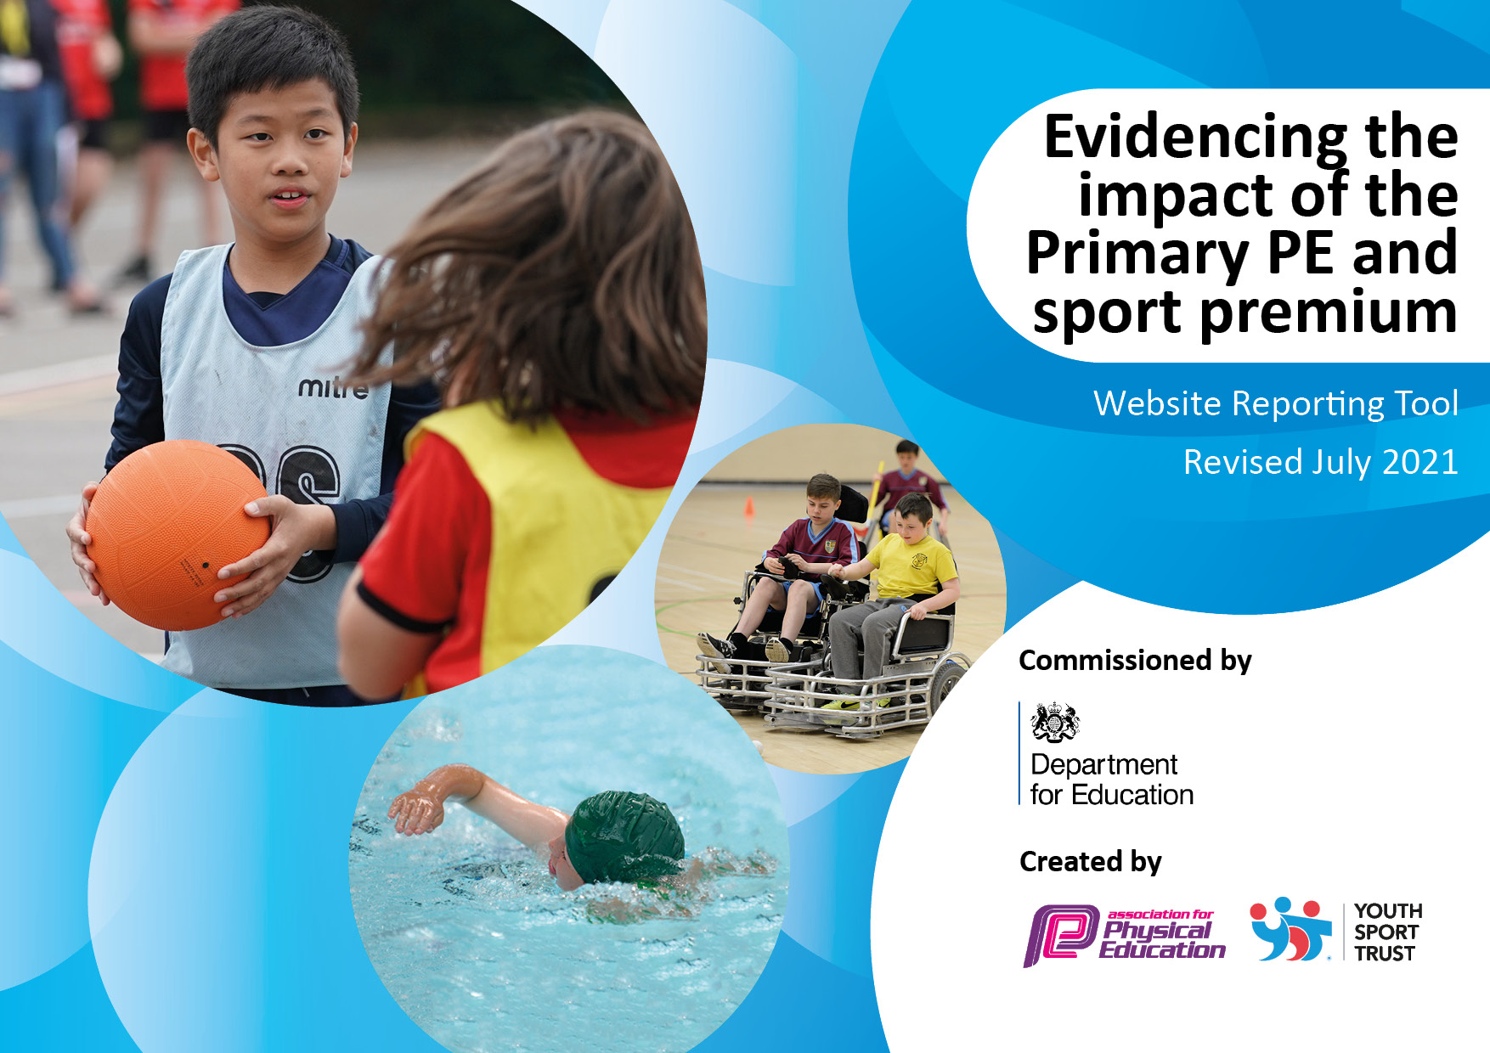
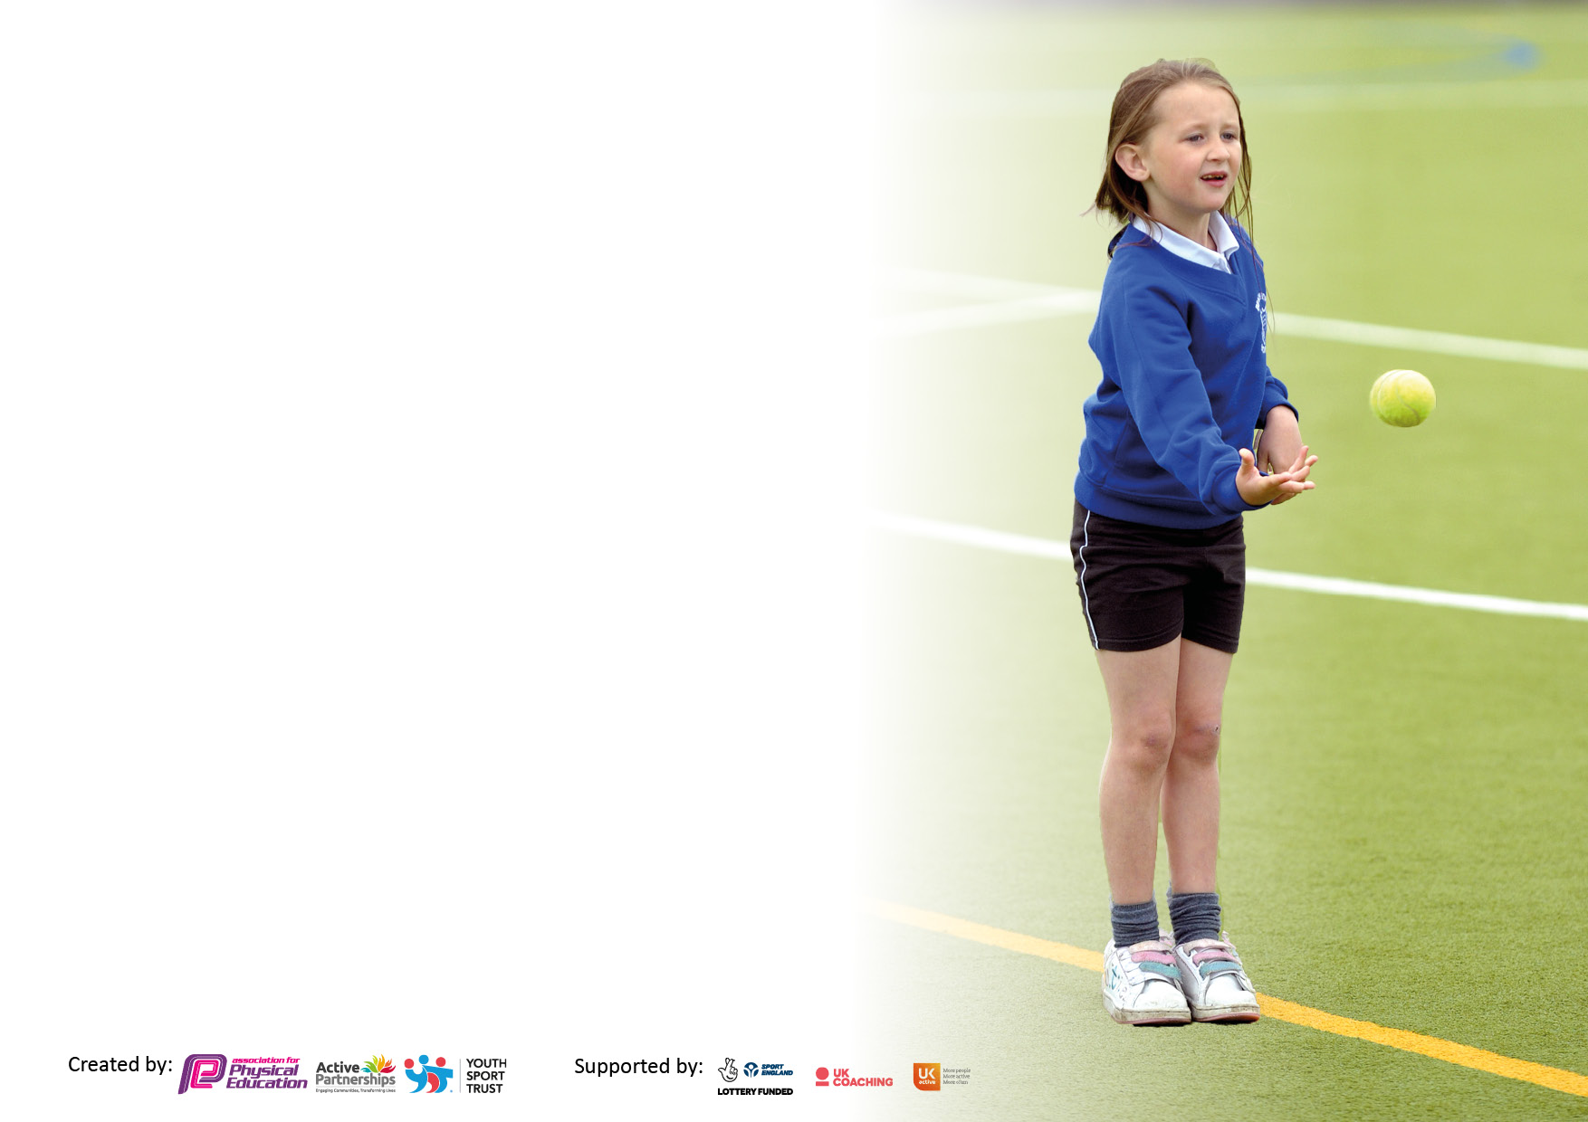

It is important that your grant is used effectively and based on school need. The Education Inspection Framework makes clear there will be a focus on ‘whether leaders and those responsible for governors all understand their respective roles and perform these in a way that enhances the effectiveness of the school’.

Under the Quality of Education Ofsted inspectors consider:
Intent - Curriculum design, coverage and appropriateness
Implementation - Curriculum delivery, Teaching (pedagogy) and Assessment
Impact - Attainment and progress

To assist schools with common transferable language this template has been developed to utilise the same three headings which should make your plans easily transferable between working documents.

Schools must use the funding to make additional and sustainable improvements to the quality of Physical Education, School Sport and Physical Activity (PESSPA) they offer. This means that you should use the Primary PE and sport premium to:

- Develop or add to the PESSPA activities that your school already offer
- Build capacity and capability within the school to ensure that improvements made now will benefit pupils joining the school in future years
- The Primary PE and sport premium should not be used to fund capital spend projects; the school’s budget should fund these.

Pleasevisitgov.ukfortherevisedDfEguidanceincludingthe5keyindicatorsacrosswhichschoolsshoulddemonstrate animprovement.Thisdocumentwillhelpyoutoreviewyourprovisionandtoreportyourspend.DfEencouragesschools to use this template as an effective way of meeting the reporting requirements of the Primary PE and sport premium.

We recommend you start by reflecting on the impact of current provision and reviewing the previous spend.

Schools are required to publish details of how they spend this funding, including any under-spend from 2019/2020, as well as on the impact it has on pupils’ PE and sport participation and attainment. All funding must be spent by 31st July 2022.

We recommend regularly updating the table and publishing it on your website throughout the year. This evidences your ongoing self-evaluation of how you are using the funding to secure maximum, sustainable impact. Final copy must be posted on your website by the end of the academic year and no later than the 31st July 2021. To see an example of how to complete the table please click HERE.
Created by: Supported by:

Details with regard to funding
Please complete the table below.

Total amount carried over from 2019/20 | £
Total amount allocated for 2020/21 | £
How much (if any) do you intend to carry over from this total fund into 2021/22? | £
Total amount allocated for 2021/22 | £19356
Total amount of funding for 2021/22. To be spent and reported on by 31st July 2022. | £
Swimming Data
Please report on your Swimming Data below.

Meeting national curriculum requirements for swimming and water safety.

N.B. Complete this section to your best ability. For example you might have practised safe self-rescue techniques on dry land which you can then transfer to the pool when school swimming restarts.
Due to exceptional circumstances priority should be given to ensuring that pupils can perform safe self rescue even if they do not fully meet the first two requirements of the NC programme of study
What percentage of your current Year 6 cohort swim competently, confidently and proficiently over a distance of at least 25 metres?  N.B. Even though your pupils may swim in another year please report on their attainment on leaving primary school at the end of the summer term 2021.  Please see note above | 27%
What percentage of your current Year 6 cohort use a range of strokes effectively [for example, front crawl, backstroke and breaststroke]?  Please see note above | 27%
What percentage of your current Year 6 cohort perform safe self-rescue in different water-based situations? | 57%
Schools can choose to use the Primary PE and sport premium to provide additional provision for swimming but this must be for activity over and above the national curriculum requirements. Have you used it in this way? | Yes

Action Plan and Budget Tracking
Capture your intended annual spend against the 5 key indicators. Clarify the success criteria and evidence of impact that you intend to measure to evaluate for pupils today and for the future.

Academic Year: 2021/22 | Total fund allocated: | Date Updated:
Key indicator 1: The engagement of all pupils in regular physical activity – Chief Medical Officers guidelines recommend that primary school pupils undertake at least 30 minutes of physical activity a day in school |  |  |  | Percentage of total allocation:
 |  |  |  | %
Intent | Implementation |  | Impact
Your school focus should be clear what you want the pupils to know and be able to do and about  what they need to learn and to  consolidate through practice: | Make sure your actions to achieve are linked to your intentions: | Funding allocated: | Evidence of impact: what do pupils now know and what can they now do? What has changed?: | Sustainability and suggested next steps:
Promote active travel:  More children to be utilising active travel to get to school rather than drive.  Teach Active:  Active lessons for all Key stages in English and Maths. To improve social skills, change attitudes and raise attainment.  Active Lunchtimes:  Key Indicator 2: Increased the amount of equipment and replaced any broken or damaged equipment.  Embed in curriculum, teaching and learning and create active environments. Less active and reluctant children to join in PE | Daily mile fully installed, promote the Daily Mile during assembly.  Active travel initiative (living street travel tracker.  To promote active learning during classroom lessons. Trail period towards the end of the 21/22 school year. Brought for 22/23.  All sport leaders trained on how to use the equipment and to play different games. All the equipment made available for the start of 22/23 school year.  Active lessons – though Teach active and CPD though St Paul’s.  Chance to Shine (Leicestershire Cricket Club)  SSPAN (Inspire together)  - Energise club  - Girls only Club  - Balance bikes  St Paul’s (feeder school)  - Balance bikes  - Numeracy in PE  - Sports Festival | £  £1170  Key Indicator 2  Key Indicator 2 | From promoting the daily mile most classes have participated in the Daily mile regularly across the year. Increase in pupil’s health and wellbeing as well as increase in concentration and attitude in lessons.  All travel methods recorded in the morning by teachers, travel badges given out when children reach a goal.  All children will be active during the school day. Increase in pupil’s health and wellbeing as well as increase in concentration and attitude in lessons.  More activities made available to the children during lunchtimes, wider range of children are more active during lunch and using equipment. A wider range of children more active and using equipment to ensure their lunches are more active and engaging.  The Cricket programmes have had a huge impact on raising the profile of PE and contributing to an overall school improvement of enjoyment and activity of pupils in PE, who were previously less active or reluctant to join in.  The clubs have had a impact og raising the profile of PE within school and the importance of being Active. | To keep the playground clean and tidy for the children to access the daily mile track.  All teachers are aware of Teach active and will be trained on how to use during the training days. All teachers will have access before the school year starts.  Use the sports leaders to run activities and matches using the equipment.  Make sure the children is regular checked for safe use.  Increase the number of targeted clubs towards the less active children. - Ensure the club is seen as a reward.  Increase staff training CPD to increase the targeted clubs.
Key indicator 2: The profile of PESSPA being raised across the school as a tool for whole school improvement |  |  |  | Percentage of total allocation:
 |  |  |  | %
Intent | Implementation |  | Impact
Your school focus should be clear what you want the pupils to know and be able to do and about  what they need to learn and to  consolidate through practice: | Make sure your actions to achieve are linked to your intentions: | Funding allocated: | Evidence of impact: what do pupils now know and what can they now do? What has changed?: | Sustainability and suggested next steps:
Celebration assembly  Every week to ensure the whole school is aware of the importance of PE and Sport and to encourage all pupils to aspire to being involved in the assemblies.  Afpe Membership:  School Games Kite mark (SSPAN)  (Also linked to Key indicator 2, 3, 4 & 5)  - Competition entry fees  - Reduced training costs (CPD)  - Festivals  - Conferences  - Links with other schools outside of the Academy  - Increased participation in the school games  - Provide existing staff with training or resources  - Provide afterschool clubs with a reduced Fee.  Equipment and Kit  To be purchased to allow teachers and staff to provide best possible lessons and learning within PE as well as continuing with the best possible provision of equipment for the children.  - SafeSport UK to check all the sports equipment, including the outdoor adventure equipment.  St Pauls Secondary School (Feeder school) Intention to compete:  - Balance Bikes  - Numercay in PE  - Young Leaders  - Sport Festivals  - CPD  Compete PE:  - Physical Activity trackers  - Assessment in PE (Age related expectations) | Assemblies have been held via teams / zoom and together depending on situations within school. Links in with Good Work Assembly on Friday afternoons.  Health and Safety updates, support how spending the PE and Sport Premium.  Continuation of the affiliation to the School Games with the SSPAN. To enable us to have access to the areas provided.  - Completed the School Games Framework for this year.  PE curriculum resources  - Staff Kit  - Lunchtime equipment  - Updated PE resources  - Laptop for complete PE and assessment.  To highlight any health and safety issues with equipment.  Continuation of the affiliation to the School Games with the St Paul’s. To enable us to have access to the areas provided.  To improve the assessment of Physical Education and Physical Activity within school. To link with the current schemes of work. | £150  £180  £1600 + £1600 for 21/22 and 22/23  £6000  £100  £50  + £7920.45 (Carried over from 20/21  £835  £1700 + Vat | Stickers and participation certificates are given to all children during sports events and activities, and to whose who attend sport festivals. Stickers are presented to participants during intra-school linking with the Games Values.  Whole impact of Above:  Pupil’s are very proud to be involved in assembles / photos on notice boards which is impacting on confidence and self-esteem.  Maintain links with other schools and staff with the City Sports Partnership. Learning from other schools best practice as highlighted by City Sports staff.  Attend conferences/meetings with the City Sports Partnership to ensure that Sacred Heart is up to speed with current developments in sporting education in Leicester. Meeting were hold and attended Via Zoom or Teams.  Silver Standard maintained for 21/22  Sports kits to be ordered to raise the profile of sport and equipment to keep kit up to date and tidy.  - Maintains high standard and good representation of the school when participating in competitions.  Staff wearing sports kit encourages and demonstrates the correct clothing to have when participating in sport. While ensuring staff feel comfortable when teaching PE.  Fixed the adventure playground equipment on KS2 playground. Removal of equipment in the foundation stage playground with the ground making safe to use.  Whole of year 1 accessed Balance bikes with all children passing level 1 and over half passing 1 and 2.  Whole school attending sport festivals experiencing competitive sport/ activities.  Whole of year completed sport leaders training.  Brought for he 22/23 academic year. Clearer assessment of PE and PA. | Use Sport Council members to manage the assemblies. Ensure all notice boards are up to date with results, clubs and matches.  To maintain the entry to the SSPAN (Inspire together) and inter school competitions.  With silver standard being maintained for the past 3 years, in 22/23 academic year. The school with attempt gold standard.  Use the SSPAN (inspire together) to access more KS1 activities and events and teachers CPD.  Regular checks on outdoor equipment:  - Football goals  - Netball posts  - Basketball posts  Maintain affiliation to St Paul’s enter more competitive activities they lead. Including football for both boys and girls.  Hold teacher training on the Compete PE website and how to use the assessment tool.

Key indicator 3: Increased confidence, knowledge and skills of all staff in teaching PE and sport |  |  |  | Percentage of total allocation:
 |  |  |  | %
Intent | Implementation |  | Impact
Your school focus should be clear | Make sure your actions to | Funding | Evidence of impact: what do | Sustainability and suggested
what you want the pupils to know | achieve are linked to your | allocated: | pupils now know and what | next steps:
and be able to do and about | intentions: |  | can they now do? What has
what they need to learn and to |  |  | changed?:
consolidate through practice:
Continued and monitored Implementation of a Whole School Scheme of Work Ensure all staff are familiar and comfortable with the use and employment of the lesson plans -Staff meeting to be held to explain and explore the Sow. -Staff training to apply and use SOW correctly and effectively | Merton Scheme of Work and Planning – Scheme to be purchased and given to all staff. -Staff to begin using SOW and CPD to aid with confidence and understanding of the scheme. To embed skills and knowledge obtained through previous years’ training and ensure a consistency in high quality PE teaching.  Brought complete PE to improve on the assessment of PE to make it clearer. | key Indicator 2 | Clear progression year upon year allowing the children to develop their skills and learn different sports. | Staff audit to be carried out at the start of the year, to plan for relevant training in staff meeting / training throughout the whole year.
Key indicator 4: Broader experience of a range of sports and activities offered to all pupils |  |  |  | Percentage of total allocation:
Intent | Implementation |  | Impact
Your school focus should be clear | Make sure your actions to | Funding | Evidence of impact: what do | Sustainability and suggested
what you want the pupils to know | achieve are linked to your | allocated: | pupils now know and what | next steps:
and be able to do and about | intentions: |  | can they now do? What has
what they need to learn and to |  |  | changed?:
consolidate through practice:
Sports Days to focus on ALL children participating in active sports and activities across the school – Increased competitiveness. Rewards (Stickers, Trophies, certificates).  Swimming boosters –Year 6  Offer Choice and Variety in PE and Sports Develop a minimum offer for all including traditional sport, alternative sport, physical activity and exercise. Competitions to be offered and entered for a wider range of children including SEND, PP, less active.  - Sports Council (linking with the school council.) | Continue to develop Sports day to be fun, enjoyable and fully inclusive for across the whole school.  As the current year 6 missed swimming in year 5 due to covid, they were undertaking 6 1-hour swimming lessons, that covered water safety and self-rescue.  Arrange a pupil survey to ascertain what pupils would like. - Involve external coaches to work with staff in clubs.  - Sports Council  Chance to Shine (Leicestershire Cricket Club)  SSPAN (Inspire Together)  - Energise Club  - Girls only club  - Specialised Fundamentals Movement  St Pauls  - Balance Bikes  - Numeracy In PE  Continue to offer a wide range of Physical activity allowing all children to access clubs. | £100  £1500  £500 | With sports day being fully inclusive allows the children to be proud of their achievements. Parents involved and enjoying the day.  Whole of year 6 improved on their swimming abilities, with 100% covering water safety and 57% being able to self-rescue.  Sports coach teaching for pupils as well as CPD for teachers. Activities and learning utilised in teachers own lessons.  A wider range of Inclusive sports activities offered to all pupils in and after school.  Children loved being part of the sports council and having a voice to choose afterschool clubs, lunch time equipment. | To model the KS2 around the Quad Kids format to allow for more competitive activities.  The current year 5 moving into year 6 to have swimming booster lessons to improve on water safety and self-rescue. As well as to meet national curriculum requirements.  Increase the amount of level 1 competitions as well as to increase inter school competitions between year groups.  Increase the number of sports council members.

Key indicator 5: Increased participation in competitive sport |  |  |  | Percentage of total allocation:
 |  |  |  | %
Intent | Implementation |  | Impact
Your school focus should be clear | Make sure your actions to | Funding | Evidence of impact: what do | Sustainability and suggested
what you want the pupils to know | achieve are linked to your | allocated: | pupils now know and what | next steps:
and be able to do and about | intentions: |  | can they now do? What has
what they need to learn and to |  |  | changed?:
consolidate through practice:
Increased participation in competitive sports – Entering more competitive sports events for all. Membership to the SSPAN:  - Competition entry fees  - Reduced training costs CPD  - Festivals  - Conferences  - Links with other Schools outside of the Academy  - Increased participation in the School Games.  - Provide existing staff with training or resources to help them teach PE and sport.  - Provide after school clubs with a reduced fee.  Entering more St Paul’s (feeder school competitions  Transport:  Transport is essential to enable our children to experience competition further afield. | To enter as many virtual and face to face competitions as possible for the children to enter in school.  School Sport & Physical Activity Network (SSPAN) membership:  - Enter an increased number of competitions from the SSPAN.  More Parallel/SEND sports event entered  Level 1 competitions allowing a wider range of children to access competitions.  Transport cost:  Transport to events to ensure the school maximises the competition calendar from SSPAN (inspire together) and St Paul’s (key indicator 2,5). Also, to allow as many children to experience and compete in competitions. | £1600 (Key indicator 2)  £835 (key Indicator 2  £3000 | Entering level 2 competitions, which gives the children a purpose to participate in sport. Maintain and create new links with other schools and staff within the City Sports Partnership. Attending conferences, CPD courses and meeting, to ensure Sacred Heart is up to date with the current developments in sport education.  Competitions provides children with a purpose to participate in sport, also enables them to learn new skills e.g. social, communication, teamwork, leadership and decision making. Competitions also promote an active lifestyle.  Sport leaders training for year 5 pupils to run sports at lunch times with both KS1 and KS2 children.  Transport is essential to enable the children to compete in competitions against other children. This provides children with a purpose for taking part in sport to learn new skills: social, communication, teamwork and leadership skills. Children are exposed and become interested in a variety of different sports which promotes a lifelong active lifestyle. | Increased opportunities for KS1 with competitions and festivals being offered with the SSPAN.  Increase competitions and events held within school both intra and inter.  To attend all competitions entered, when returning the intention to compete form to the SSPAN, to increase the number of children participating in level 2 competitions.  Make sure we attend all the competitions we enter. Enter football tournaments.  To maximise travel next year to competitions either ran by SSPAN (inspire together) or ST Pauls (secondary feeder school). To enter more children/teams into competitions to allow more children experience competitive sport.

Signed off by
Head Teacher:
Date:
Subject Leader:
Date:
Governor:
Date:

