June 2022
Sacred Heart Catholic Voluntary Academy

As I wite this newsletter, there are only 4 whole weeks left of the 2021-2022 school year. It has absolutely flown past, but it has been a very positive year for the school.  Coming back to ‘normal’ school after such disruption from the pandemic has been wonderful. We have still been cautious and have managed to keep cases relatively low. I congratulate the staff for making sure that your children have been very well protected by hand washing, cleaning etc.  We have now started to take the children on some trips- we had a very successful residential with year 6 and most year groups have been able to visit St Pauls for a sports session. Our annual Saffron Lane sports event was excellent, and a few of our children won medals- well done!  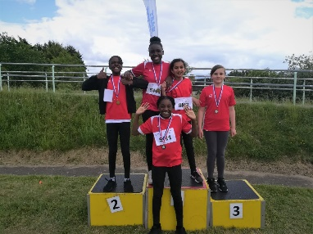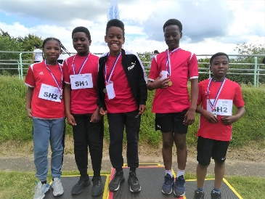  Eco work  We continue with our Eco Award work. Just before half term, we welcomed Geoff and Keith from the ‘Wombles’ team in for an assembly on reducing litter and keeping the planet clean. It was informative.  Leavers  Good luck to all of the children who will be leaving us this year to go to high school or pastures new.  We also have a few members of staff who will be leaving:  Mrs Mulroe who is retiring  Mrs Ard who is also retiring  Miss Bourne- Williams who is having a change of career  Mrs Overthrow, in the kitchen, who is moving to a different area  We send them all off with our love and best wishes. The school will never be the same without you all. | Dates for your diary  Year 4 multiplication check- week beg. 13/6/22  Year 5 trip to St Paul’s- drama day- 13/6/22  Year 5 trip to St Paul’s- art ‘taster’ day- 15/6/22  All children- NSPCC assembly- 24/6/22  Chinese children’s day- 28/6/22  Year 6 Transition Day- 29/6/22  Year 6 Graduation Ceremony- 1:30pm 1/7/22  Leaver’s Mass- 1:30pm 5/7/22 Year 6 parents invited  School finishes- THURSDAY 7/7/22  No school on Friday the 8th of July  School opens for children- Monday 29th August 2022  New entrants to F1 and F2 will be notified of start dates/times
Reports and new classes for next year
The teachers are busy writing reports for the children now. You should receive these towards the end of the year via email.

Prayers
As many of you will have heard, Mr Hirst, our former Headteacher, passed away just before half term. Many members of staff worked with Gerry for many years and so it was a difficult time for us.

We had a plaque made to commemorate his life- this now sits on the bench outside the office with plaques for Mr Kaminski and Eva. May they all rest in peace.
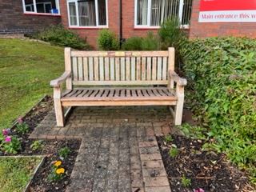

Prayer: Eternal rest grant unto them, O Lord, and
let perpetual light shine upon them. May the souls of all the faithful departed, through the mercy of God, rest in peace. Amen.

Please have a happy and safe summer and we will see you back

