November 2022
Sacred Heart Catholic Voluntary Academy

This term is going so quickly…. There are only 3 more Mondays to go until the Christmas break.  Some important news  After Christmas, Mrs. Hayles will be reducing her working days to Monday, Tuesday, and Wednesday. On Thursdays and Fridays, Mrs. James will take over as Headteacher.  Uniform thank you  Thank you so much for making sure your children are looking as smart as possible- the difference is noticeable.  Christmas collection  You will have received a letter from Mrs Conaghan, asking for items to make up Christmas hampers. Five Catholic schools are working together on this project, so please support us.  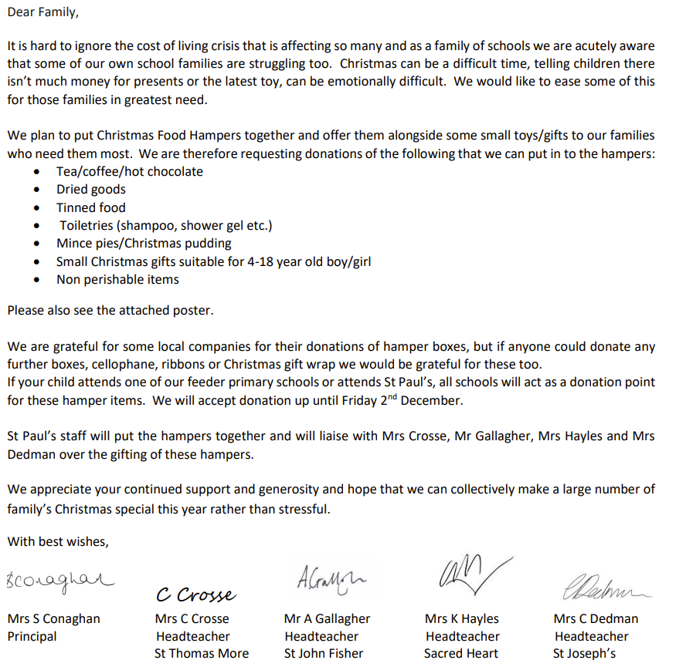  Happy Christmas to you all,  from everyone at Sacred Heart. | Dates for your diary  Friday 2nd December- Menphys choir at De Montfort Hall 7pm- tickets available at the box office  Monday 5th December- Cathedral Choir auditions  Wednesday 7th- Trust Travelling Advent Crib arriving  Wednesday 7th- KS1 play to parents at 1:30pm and 5pm- details to follow  Thursday 8th- Wear blue for Lourdes- 50p donation  Thursday 8th- Foundation Stage play- 10:00 am and 1:30 pm- details to follow  Wednesday 14th- Christmas dinner and jumper day  Wednesday 14th- Christmas disco- details to follow  Thursday 15th- Rock steady music assemblies  Friday 16th- school closes at 1:30pm  Tuesday January 3rd- school re-opens
We have spaces in many year groups

If you know of any friends or family members who are looking for a school for their children, please contact the office staff to arrange a visit.

Your prayers please

We recently heard two pieces of very sad news:
a little boy from the nursery in St Patrick’s school very sadly died. He was three years old.
Also, you may have seen in the news that an ex-pupil of Christ the King and English Martyrs, Rheiss McLean also passed away.

May their souls rest in eternal peace.

